LESSON NOTES
FOR P.1

LITERACY

TERM III

Date | Class | L. Area | No. of children | Time
THEME : Transport
SUBTHEME : Types of transport
COMPETENCES : A learner
- defines the term transport
- identifies types of transport
- reads, spells and pronounces the words correctly
- draws the types of transport
METHODS : Guided discovery
- Observation
- Question and answer
CONTENT : Transport
It is the movement of people with their goods from one place to another.

Types of transport
There are four types of transport.
- Road transport
- Water transport
- Railway transport
- Air transport

Exercise
- _____is the movement of people and their goods from one place to another
- Mention four types of transport
- ______________ c) __________________
- _____________ d) _______________
- Draw the following types of transport
Water | Road | Railway | Air

- Listen and write
- Who teaches pupils at school? __________
- Mention two people found at school

Date | Class | L. Area | No. of children | Time
THEME : Transport
SUBTHEME : Types and their means (road)
COMPETENCES : ALearner
- defines road transport
- identifies the means of road transport
- reads, spells and pronounces the words correctly
- draws and names means of road transport
- state people who we road transport
METHODS : Guided discovery
- Guided discussion
- Question and answer
CONTENT : Road Transport
- This is the movement of people with their goods on land.
- Most common type of transport.

Types of roads
- Tarmac roads
- Murram roads
Thematic book pg 96 x 99
Text book teaching kobta
Means of road transport
- Bus, bicycle, car, lorry, motorcycle, horse, camel, donkey, carts, foot
People who use road transport
- Pedestrians, drivers motorists, passengers, cyclists / riders
Exercise
- __________transport is the movement of people and goods on land.
- Write four means of road transport
- _________________ c) _________________
- _________________ d) _________________
- Draw these means of road transport
Bus | car
bicycle | lorry

- Listen and write
- Circle common diseases
flu TB malaria cough causer
- Why do we eat food?
Date | Class | L. Area | No. of children | Time
THEME : Transport
SUBTHEME : Types and means of transport
COMPETENCES : A learner
- defines water transport
- states the means used on water transport
- read, spell and pronounce the words correctly
- draws means of water transport
- states people who use water transport
METHODS : Explanation
- Observation
- Question and answer
Text book teaching
CONTENT : Water Transport
- Is the movement of people with their goods on water
- This is the slowest type of transport
- It is the cheapest types of transport
- It is used to transport heavy things like machines
Mean of water transport
- Boats, ferries, yacht, canoes, ships
People who use water transport
- Sailors, captain, navigators
- Captain – operates a ship.
- Sailor – sails a boat
- Navigators – people who travel by water
Problems faced by people who use water transport
- Bad weather
- Dangerous animals e.g. crocodiles
Exercise
- Write the means of transport for the following types of transport
- Water transport : _______________ _______________
- Road transport :_______________ _______________
- A person who sails a ship is a _______________
- A person who sails a boat is a _______________
- Write two people who use water transport
- Draw these means of water transport
Boat | ship
- Draw these energy giving food
Cassava _______ yam _______ maize _______
- What is food? ___________________

Date | Class | L. Area | No. of children | Time
THEME : Transport
SUBTHEME : Types and means of transport
COMPETENCES : A Learner
- defines Air transport
- states the means used on air transport
- reads, spells and pronounces the words correctly
- draws means of air transport
- states people who use air transport
METHODS : Brain storming
- Guided discovery
- Question and answer
CONTENT : Air Transport
Movement of people with their goods above water and land
- It’s the most expensive type of transport
- It is the quickest type of transport
Mean of air transport
- Aeroplanes
- Helicopters
- Parachutes
- Rockets
- Jet fighters
People who use air transport
- Air hostess work are woman who work in the aeroplane.
- Pilots, navigators and passengers eg. business people and tourists
- It is also used to transport fragile things eg. fruits, glasses etc.

People who fly planes are called -
- Pilots

Exercise
- Listen and write _____ ____ ___ ____ _____
- A person who flies an aeroplane is a _________ ( driver, pilot)
- Read and draw
An aeroplane ________ helicopter ________
- Give three means of air transport.
- Which is the quickest and most expensive type of transport
- Which is the cheapest and slowest means of transport?
- Mother uses an ___________ to travel to London.
- Give two roles of father at home
- Circle examples of fruits,
Meat, mango, eggs, pineapple

Date | Class | L. Area | No. of children | Time
THEME : Transport
SUBTHEME : Types and means of transport
COMPETENCES : A Learner
- defines railway transport
- states the means of railway transport
- identifies the places where we find different means of transport
- reads, spells and pronounces the words correctly
- draws the means of railway transport
- construct sentences using the learnt words
METHODS : Guided discussion
- Guided discovery
- Question and answer
CONTENT : Railway Transport
This is the movement of people with their goods on rails.
These rails are built on land.
Means of railway transport
A train: is also used to carry heavy things eg food
People who use railway transport
Captain – operates a train/ passenger
Places where we find different means of transport.
- Train – railway station
- Car – parking yards / car park
- Buses – bus parks
- Taxis – taxi park
- Aeroplanes – airports/ air strips
- Boats/ ferries – harbours

Exercise
- Fill in the missing letters.
R ___ ___lway tr__ __ n r__ils
Bus p__rk b___ ___ t a __roplane
- Draw a train.

- Match correctly
Bus airport/ air strips
Train Taxi Park
Car railway station
Aeroplane bus park
- Name the slowest means of transport.
- A ______ moves on railways.
- Who grows crops and keeps animals in a community
- Who traets sick people in a hospital?

Date | Class | L. Area | No. of children | Time
THEME : Transport
SUBTHEME : Road safety
COMPETENCES : A learner
- defines road signs
- identifies different road signs and their meanings
- reads, spells and pronounces the words correctly
- draws and names the road signs
METHODS : Guided discussion
- Guided discovery
- Question and answer

CONTENT : Road signs
- These are symbols used road to guide road users
- They help in reducing traffic jam and road accidents
Examples of road signs

- Parking
- Traffic lights
- No parking
- School ahead
- Zebra crossing
- Round about
- Humps ahead
- Stop
- Accident ahead
- Railway crossing
- Bridge
- Men at work

Exercise
- Name the road signs

!

- Write any one importance of road signs to road users.
- Listen and write
- Identify two domestic birds
- Write the name of your headteacher

Date | Class | L. Area | No. of children | Time
THEME : Transport
SUBTHEME : Road safety
COMPETENCES : A Learner
- Identifies the threecolours of the traffic lights
- Tells the meanings of the traffic lights
- Mentions the safe and unsafe ways of using the road
- Spells reads and pronounces words correctly
METHODS : Guided discussion
- Guided discovery
- Question and answer

CONTENT : Traffic lights
There are three colours of the traffic lights
- Red
- Orange
- Green
Meaning of traffic lights
- Red – stop
- Orange – get ready
- Green – go
Safe ways of using the road
- Use zebra crossing, it is a safe place to cross from
- Obey traffic rules
- Do not cross the road while running
- Following the traffic lights
- Walk in a single line on the road
- Look right, look left and look right again, the cross.
- Use foot paths for pedestrians on the road
Unsafe ways of using the road
- Playing on the road
- Grazing on the road
- Over loading of cars
- Over speeding of cars
- Driving while drunk

Exercise
      - Name the three colours of the traffic lights
      - Write the meaning of the traffic lights
      - Read means __________
      - Orange means __________
      - Green means ____________
      - Underline the safe ways of using the road
      - Follow the traffic lights, over speeding
      - Obey traffic rules
      - Why is it good for you to follow road signs?
      - A person who walks on the road is called a_____
      - Why is it bad to run while crossing the road?
      - Write the name of your school

Date | Class | L. Area | No. of children | Time
THEME : Transport
SUBTHEME : Road safety
COMPETENCES : A learner
- Identifies the dangerous things on the road
- Read , spell and pronounce the words correctly
- Write the spellings correctly
METHODS : Guided discussion
- Guided discovery
- Question and answer
CONTENT : Dangerous things on the road
- Broken bottles
- Broken electric wires
- Over speeding cars
- Falling trees
- Pot holes
- Nails
- Stones
- Snakes

Exercise
      - Identify four dangerous things on the road
  - ________________ c) _______________
  - _______________ d) _______________
2. Draw these dangerous things on the road
Nails | Stones | Broken bottles | Cars

3. Write down any two good ways of using the road.
4. What is the meaning of the following road sign?
5. Match food to their classes
Maize body building food
Mango energy giving food
Eggs healthy giving food
- Draw these accidents
Falls ___________ strings _________

Date | Class | L. Area | No. of children | Time
THEME : Transport
SUBTHEME : Road safety
COMPETENCES : A learner
- Identifies the causes of road accidents
- Read the words correctly
- Spell and pronounce the words correctly and control measures
METHODS : Guided discovery
- Question and answer
CONTENT : causes of road accidents
These are things that may lead to accidents on the road.
Examples
Over loading/ bicycles/ motorcycles.
Talking on phone while driving
Over speeding drivers
Drunken drivers
Pot holes
Slippery roads
Bad weather
Driving vehicles in bad mechanical condition.
Bad roads

How to control accidents on road
- Cross on the Zebra crossing
- Follow the road signs
- Avoid playing on the road
- Follow traffic rules
- Proper disposal of broken bottles and glasses

Exercise
      - Underline the causes of road accidents
Drunken driver, following road signs ,
pot holes bad roads
      - Mention three accidents at home
      - An ___________is a sudden happening that causes harm or injury to the body.
      - What are domestic animals?
      - Give three examples of domestic animals.
      - How is a zebra crossing useful to road users?
      - Listen and write
      - Name the dangerous objects


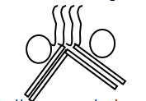

Date | Class | L. Area | No. of children | Time
THEME : Transport
SUBTHEME : Road safety
COMPETENCES : A Learner
- States the importance of transport.
- Identifies the most expensive, cheapest, commonest and quickest type of transport.
- Identifies ways of controlling accidents
- Reads , spells and pronounces the words correctly
- Writes the words correctly

METHODS : Guided Discussion
- Guided discovery
- Question and answer

CONTENT : Importance of transport
- Carrying people ( transport people)
- Carrying goods
- Carrying animals
- Carrying water
- Employing people
- Earning money
- Transport school children

Comparing transport
- Most expensive – air transport
- Cheapest – water transport
- Commonest – road transport
- Quickest – air transport
- Slowest – water
Exercise
- Mention the importance of transport
- Draw these things we us to clean our body.
Soap | Sponge | Tooth brush | Towel

- Draw and shade the traffic lights.
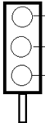

- Which type of transport I;
  - The commonest - ________________
  - The slowest - ____________________
  - The fastest - _____________________
- Fill in the missing letters
exp __nsiv___ ch ___ ___p tr ___nsp___rt
g __ __ds
- Draw and name three things made out of wool
End of theme test
- How do we call the movement of people with their goods from one place to another?
- Identify the four types of transport
______ _______ ________ __________
- Match correctly
bus water transport
train air transport
aeroplane railway transport
ship road transport
b) which means of transport can you use to go to London?
- Name the means of transport

- Which is the most expensive type of transport?
- Draw to show a train
- Name the cheapest and slowest type of transport
- Draw and name four means of road transport
- Write their titles
A person who drives a bus
A person who flies an aeroplane
People who travels in a bus
A person who rides a bicycle

Date | Class | L. Area | No. of children | Time
THEME : Things we make
SUBTHEME : Things we make at home
COMPETENCES : A Learner
- Identifies the things we make at home
- Reads , spells and pronounces the words correctly
- Draws the things we make at home
- Writes the words correctly
METHODS : Observation
- Guided discovery
- Question and answer
- Illustration
CONTENT : Things we make

Things we make at home
Play things E.g. Balls, ropes, toy cars, mats, dolls
Kitchen tools (things we use in the kitchen)
E.g. Basket Pots , Mortar , Pestle ,
- Charcoal stove , Mingling stick
- Winnower
- Plate and cups

Exercise
- Identify four examples of things we make
- Draw these things we make at home
basket | mortar | pestle | plate
balls | ropes | toy cars | dolls
mats

- Listen and write
- Name these house
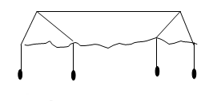

- ______ is the daily condition of place recorded for a short period of time
Date | Class | L. Area | No. of children | Time
THEME : Things we make
SUBTHEME : Things we make at home
COMPETENCES : A Learner
- Defines the terms’ furniture’ and crafts
- Identifies examples of furniture and crafts
- Reads , spell and pronounce the words correctly
- Draws and names examples of furniture
METHODS : Guided discussion
- Guided discovery
- Question and answer

CONTENT : Furniture
Furniture are things made out of wood
Furniture used at home
- Tables, chairs, beds, cupboards, stools, doors, windows
Crafts
- Crafts are things we make out of local materials using hands e.g ornaments i.e. bangles, necklaces, earrings, finger rings , our decorations for houses.

Exercise
- Things made out of wood are called ____________
- Write three examples of furniture.
- Draw these examples of furniture used at home.
Tables | Chairs | Beds
Windows | Doors | Stools

- Write the uses of these things we make
Chairs __________________
beds ___________________
doors __________________
- Name the person who makes furniture
- How do you come to school?

Date | Class | L. Area | No. of children | Time
THEME : Things we make
SUBTHEME : Things we make at home
COMPETENCES : A Learner
- Identifies the clothes we make and use at home
- Reads , spells and pronounces the words correctly
- Draws and names the clothes we use at home
- Writes the words correctly
- Constructs sentences correctly
METHODS : Observation
- Guided discovery
- Question and answer
CONTENT : Clothes we make at home

Clothes are things we make to wear e.g.
- trousers
- sweaters
- shirts
- dresses
- shoes
- jackets
- coats
Other things we make to wear
- belts
- hats
- shoes
- bags
- stockings
- gloves

Exercise
- What are clothes?
- Identify three examples of clothes we make.

- Read and draw these clothes we wear
shirt | trouser | hat
dress | belt | shoes
- Match animals to their products
Pig chicken
Cow mutton
Sheep pork
Goat beef
- What is the use of a hoe?
- Draw a panga

Date | Class | L. Area | No. of children | Time
THEME : Things we make
SUBTHEME : Things we make at school
COMPETENCES : A learner
- States the things we make at school and the tools we make at home.
- States material used for making things.
- Draws and names things we make at home
- Writes the words correctly
METHODS : Demonstration
- Guided discovery
- Observation
CONTENT : Things we make at school
These are things we make to be used at school
Examples are
- mats, ropes, balls , toy cars, dolls, pot etc
These thing are locally made using local materials
Materials used for making these things
- banana fibres , clay, papyrus , sisal ,threads ,raffia ,
- papers ,grass , mud , palm leaves, beads
Tools we make at home
Hoes, slasher, knives, rakes, pangas, wheel barrow, axe.
Exercise
- Name these things we make at school

- Make balls dolls(practical)
- Match materials to things they are made of
doll banana fibres
pot palm leaves
rope sisial
mat clay
- Fill in the missing letters
d __lls s __sal sh ___s
Date | Class | L. Area | No. of children | Time
THEME : Things we make
SUBTHEME : Materials we use to make things
COMPETENCES : A learner
- Identifies materials used to make things
- Matches things we make to their materials
METHODS : Question and answer
- Guided discovery
- Observation
CONTENT : Things we make and their materials
Practical lesson
Children should see some of these materials and things made out of them.
Mats : palm leaves
Pots balls : clay
Balls : banana fibres
Dolls : banana fibres
Winnowers : sticks straws sisal
Brooms : grass
Granary : stick sisal
Mortar : wood
Pestle : wood
Charcoal stove : clay
Basket : sisal grass
Table mats : threads
Exercise
- Write materials used to make these things.
brooms pot basket pestle
_______ ____ _____ ____
- Fill in the missing letters
M__rtar cl___y p__lmleaves
- What do we make out of the following materials
Wood _____________ _____________
Threads ___________ _____________
Clay ______________ _____________
- Give three important places in the community
- Draw a hospital

Date | Class | L. Area | No. of children | Time
THEME : Things we make
SUBTHEME : Sources of materials
COMPETENCES : A Learner
- Identifies sources of materials
- Draws sources of materials
- States the uses of things we make.
METHODS : Question and answer
- Guided discovery
CONTENT : Source of materials
Swamps : clay , papyrus reeds
Forest : timber, wood, back cloth
Plants : banana fibres, palm leaves, sisal
Lake : shells
Animals : skin/ bones
Bush : raffia
Uses of things we make
Mat ___ siting on
Balls ____playing football
Dolls ____ playing with
Brooms ____sweeping
Stools _____sitting on
Ropes _____skipping
Bricks _____building
Exercise
- Write down four sources of things we make
- Draw these sources
Swamp | Lake | Palm tree | Bush

- Listen and write
- Write their uses

______________
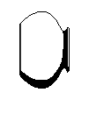
____________
_________________
______________
_______________
_____________
- Draw a girl sitting on the mat

- Listen and write
- Where do people cross a busy road?
- Draw to show danger a head
- Give two uses of water

REVISION : Things we use for playing
- Balls
- Doll
- Kites
- Balloons
- Toy cars
- Ropes

Exercise
- Write five things we used for playing
- Draw these play things.
Kites | Balloons | Toy cars

- Draw two things we make for decoration
- Name things we make for home use
- Name these things we make for playing.

End of theme test things we make
- Draw and name four examples of things we make at school

- Match things we make to their uses
Toy car sitting on
Bag playing with
Cup carrying books
Charcoal stove cooking food
Mat drinking from
- Name these clothes we wear
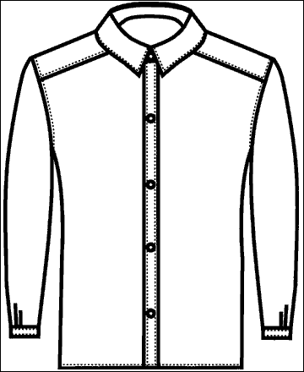
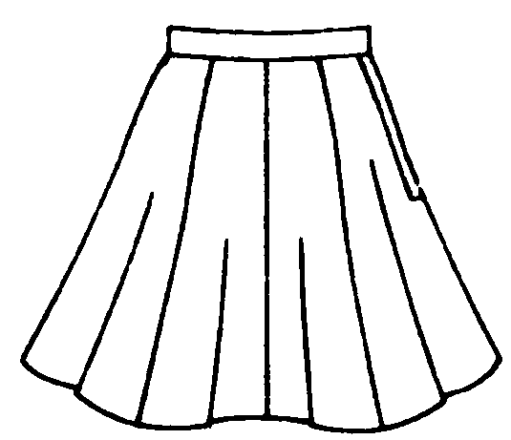
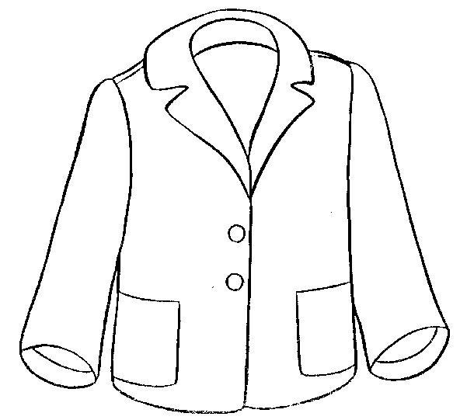

- Match things we make to the materials used
Pot grass
Mat clay soil
Mortar / pestle palm leaves
Broom wood
- Of what importance is a panga?
- Identify three things we make out of wood
- Give three examples of ornaments
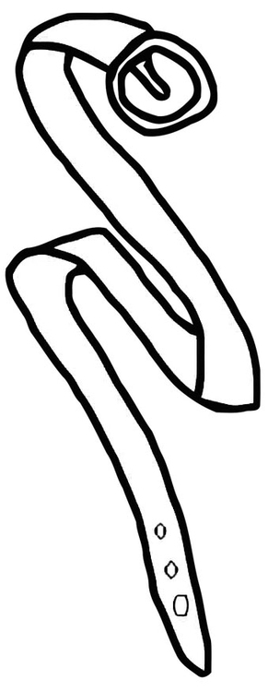
- Name these things we get from animal skins

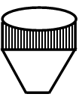
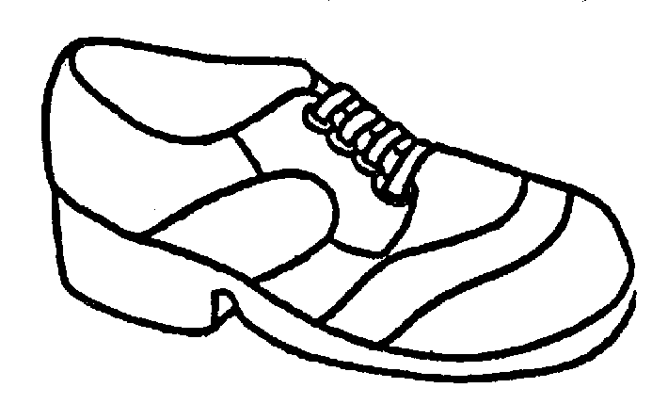

- Draw to show the means of road transport
Lorry _________ horse ___________
LESSON
Things we make at home and at school
mats, drum, sticks, shakers, boots, dolls, balls, rope, baskets, pots, hats, winnowers, table mats,
decorations
Question
- Draw and name any four things we can make at home and at school.
Balls | Pot | hat

Materials used to make things at home and at school
sisal, clay, banana stalks, sticks, tins, cloth, palm leaves, threads, papers, seeds, bottle tops

LESSON
Sources of materials we use to make things at home and at school
swamps, wetland, bush, forests, plants
What do we get from swamps?
- clay
- papyrus
What do we get from forests?
grass, wood, sticks, firewood, herbs, reeds, raffia, palm leaves
Things we make for playing
dolls, ropes, balls, toys
Things we make for domestic use
Mats , baskets, mingling sticks, walking sticks.
Things we make for sale
dolls, baskets, toys, pots, ropes, balls, bags, flower vases, mats, hats , carpets, door mats , table mats
Things we make for decoration
table mats , table, clothes, paper collage , frames

Date | Class | L. Area | No. of children | Time
THEME : Our environment
SUBTHEME : Things in our environment
COMPETENCES : A Learner
- Defines environment
- States components of the environment.
- Draws things in our environment
- Spells, reads, and pronounces words correctly.
- Writes the words correctly
METHODS : Brain storming
- Guided discovery
- Question and answer ( out side class room lesson)
CONTENT : Our environment
What is environment?
Environment are the natural surroundings of man.
Components of theenvironment(These should be drawn )
- Plants,
- hills,
- animals ,
- mountain
- birds,
- river,
- Land/ soil,
- people,
- insects,
- lakes
- valleys
- swamps
- air

Exercise
- Write down six things in our environment
- Fill in the missing letters
Pl__nts b__rds P__ __ple env__ronm__nt
- Draw these components of the environment
Plants | Animals | Birds | Insects

- ___________ are the natural surroundings of man (mountain, environment)
- How do we call things made out of wood?
Date | Class | L. Area | No. of children | Time
THEME : Our environment
SUBTHEME : Components of environment
COMPETENCES : A Learner
- Define living things
- Identifies characteristics of living things
- Mentions examples of living things
- Spells, reads and pronounces the words correctly
- Writes the words correctly
METHODS : Guided discussion
- Guided discovery
- Question and answer
CONTENT : Living things
These are things which have life
Characteristics of living things
- They feed
- They grow
- They respire
- The reproduce
- They excrete
- They move
Examples of living things
- Animals
- Plants
- Insects
- Birds
- People
Exercise
- What are living things?
- Give four examples of living things
- Identify three characteristics of living things.
They ____________________
They ____________________
They ____________________
- Name these living things
- Draw a winnower
- What is wind?

Date | Class | L. Area | No. of children | Time
THEME : Our environment
SUBTHEME : Components of the environment
COMPETENCES : A learner
- Defines non- living things
- Identifies characteristics of non – living things
- States examples of non – living things
- Spells – reads and pronounces the words correctly
- Writes the words correctly
METHODS : Brain storming / guided discovery
CONTENT : Non- living things
These are things which do not have life
Characteristics of non – living things
- They do not feed
- They do not grow
- They do not respire
- They do not reproduce
- They do not excrete
- They do not move
Examples of non – living things
- Stones
- Hills
- Valleys
- Lakes
- River
- Rocks
- Stars
- Moon
- Sun
- Clouds
- Land/ soil
Exercise
- _______are things which do not have life.
- State four examples of non – living things
- Draw these non – living things
Hill | lake | river | stone | sun | moon
- Listen and write
- Mention the four seasons
- Name these domestic birds

- Draw a necklace

Date | Class | L. Area | No. of children | Time
THEME : Our environment
SUBTHEME : Components of the environment
COMPETENCES : A Learner
- State the importance of non – living things in our environment
- Reads and pronounces words correctly.
- Writes the words correctly
METHODS : Guided discovery / brain storming
:
CONTENT : Importance of non – living things in our environment
- Some stones and sand are used for building houses.
- Lakes and rivers provide us with fish and water.
- The sun, moon and stars provide us with light.
- Land/ soil are used for growing crops.
- Nimbus clouds give us rain
Exercise
- From lake we get __________ and __________
- The __________ give us light during day and the ___________ gives us light at night.
- _____________ Clouds gives us rain.
- Give three examples of food.
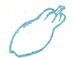
- Name these fruits



- Who teaches you literacy?
- Identify the four types of weather

Date | Class | L. Area | No. of children | Time
THEME : Our environment
SUBTHEME : Animals
COMPETENCES : A Learner
- Defines domestic animals
- Identifies examples of domestic animals
- Draws domestic animals
- Reads and pronounces the words correctly
- State the importance of domestic animals
METHODS : Guided discovery
- Question and answer
- Observation
: Types of animals are:-
- Domestic animals
ONTENT : Domestic animals
These are animals kept at home

Examples

- Dog
- Cow
- Sheep
- Pig
- Rabbit
- horse
- goat
- donkey

Exercise
- What are domestic animals
- Mention six domestic animals
- Draw these domestic animals
Cow | Dog

- Why do we brush our teeth
- __________ is the sudden happening that may cause harm to the body.
- Draw to show a nurse.
Date | Class | L. Area | No. of children | Time
THEME : Our environment
SUBTHEME : Importance of domestic animals
COMPETENCES : A Learner
- Identifies importance of domestic animals
- Draws animal products
- Writes the words correctly
- Reads, spells and pronounces the words correctly
CONTENT : Importance of domestic animals

- We get meat , milk, skins
- Dogs guard our homes
- Sheep gives us wool.
- Cats chase away rats
- We sell them and get money
- Some are used for transport eg. donkeys, horses
Exercise
- Give two uses of domestic animals
            - ________________
            - _________________
- Mention two animals used for transport
        - ______________
        - ________________
- Draw a dog chasing a thief.

- Draw these animals we use for transport
Horse _______________ donkey ________
- Name these things we use to clean our body
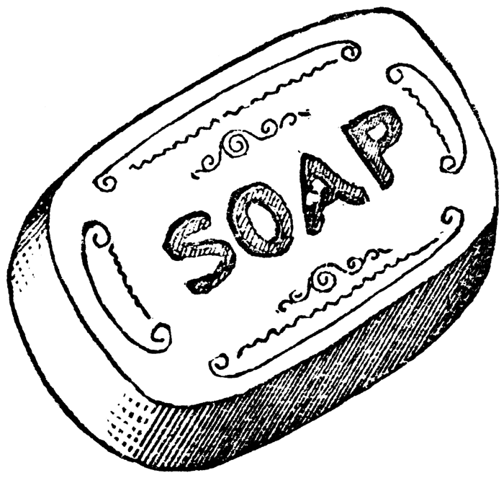

- Which bird gives us chicken and eggs

Date | Class | L. Area | No. of children | Time
THEME : Our environment
SUBTHEME : Animals
COMPETENCES : A Learner
- Defines wild animals
- States examples of wild animals
- Read, spells and pronounces the words correctly
- Identifies places we find wild animals
- Identifies uses of wild animals and dangers of wild animals
- Writes the words correctly
METHODS : Guided discovery
- Question and answer
- Observation
CONTENT : Wild animals
These are animals which live in the bush / forest.
They are also kept in the zoo and game parks.
Examples are
- Elephant , Zebra , Buffalo , Monkey , Snake ,
- Giraffe,Kangaroo, Hyena , Lion etc.
Places where we find wild animals
- Bushes
- Forests
- Lakes
- Rivers
- Zoo
- mountains
Dangers of wild animals
- Snakes bite people
- Monkeys spoil farmers crops.
- They eat smaller domestic animals
- They eat people e.g. lion

Importance of wild animals
- Some are eaten as food.
- They attract tourists.
- They are used for learning purposes.

Exercise
- Draw and name four wild animals.
- Fill in the missing letters
el_ph_nt L _ _pard L _ _n
- Read and draw
Lion | Elephant | Monkey
4. How are wild animals dangerous to us?
They can ___________
They can ___________
5. Identify three school symbols
6. Draw a school badge
7. Which animal spoil farmers crops

Date | Class | L. Area | No. of children | Time
THEME : Our environment
SUBTHEME : Animals
COMPETENCES : A learner
- States things we get from animal skins.
- Mentions the animal young ones.
- Reads, spells and pronounces words correctly
- Writes the words correctly
METHODS : Guided discovery
- Observation
CONTENT : Things we get from animal skins
bags shoes belts drums
blankets jackets costumes

Animals with their young ones
Cow - calf
Dog - puppy
Lion - cub
Duck - duckling
Fish - fry
Cat - kitten
Goat - kid
Monkey - baby
Man - baby
Pig - piglet
Bird - nestling
Sheep - lamb
Hen - chick
Elephant - calf
Bird - nestling
Rabbit - bunny

Exercise
- Match animals to their young ones
Cow piglet
Dog cub
Lion duckling
Fish kitten
Cat calf
Goat fry
Pig puppy
Duck kid
- Fill in the missing letters
K_tt_n P_ppy C_ _ f
- How are the following animals useful to us
  - Cow __________
  - Dog __________
  - Cat __________
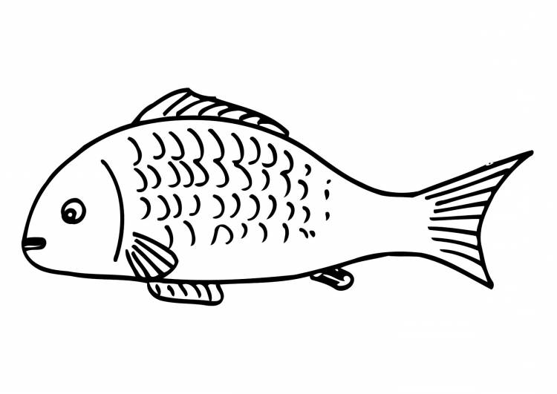
- Name the body building food

- Where do sick people go for treatment
Date | Class | L. Area | No. of children | Time
THEME : Our environment
SUBTHEME : Animals
COMPETENCES : A Learner
- Defines some animal sounds
- Imitates the sounds
- Matches animals to their sounds.
- Reads, spells and pronounces words correctly.
- Writes the words correctly
METHODS : Guided discovery
- Question and answer
- Observation

CONTENT : Animal sounds
Different animals make different sounds as a way of communication.
For example
Cow - moos Dog - barks
Baby - cries Snake - hisses
Lion - roars Pig - grunts
Cat - mews/ purrs Donkey - brays
Frog - croaks Horse - neighs
Duck - quacks Sheep - bleats
Monkey - chatters Elephant - trumpets
Bird - sings Cock - crows
Bull - bellows goat - bleats

Exercise
- Match animals to their sounds.
Cow roars
Dog hisses
Duck barks
Snake moos
Lion quacks
2. Fill in the missing
h_sses d_g b_ _ks sn_k_
3. Write the young ones of the following animals.
  - Pig
  - Bird
  - Man
  - Hen
- Write their uses
              - Panga
              - Basket
              - Knife
- Where do we buy food from?

Date | Class | L. Area | No. of children | Time
THEME : Our environment
SUBTHEME : Animals
COMPETENCES : A learner
- Identifies different homes of animals
- Spells , reads and pronounces the word correctly
- Matches animals to their homes
- Writes the words correctly
METHODS : Guided discovery
- Question and answer
- Observation
CONTENT : Animal homes

What are animal homes?
These are places where animals live or sleep.
Different animals have different homes

Homes of different animals
Animals Home
Cow kraal / byre
Dog kennel
Lion den
Bird nest
Goat shed / pen
Rabbit hutch
Pig sty
Bee hive
Horse stable
Man horse
Monkey tree
Snake burrow
Hen cage/ fold
Exercise
- What are animal homes?
- Match animals to their homes
Cow sty
Goat hive
Pig kraal
Bird goat shade
Bee nest
- Fill in the missing
H_tch kr_ _l h_ve k __nnel h__use st__
- Draw these homes
nest ________________ hive ________________
- Write down four people found at school
- What is a home?
- Who heads a family?
- Draw these building materials
grass ____________ sand ___________
Date | Class | L. Area | No. of children | Time
THEME : Our environment
SUBTHEME : Products got from Animals
COMPETENCES : A Learner
- Identifies different things we get from animals
- Reads, spells and pronounces the words correctly
- Write uses of things we get from animals
- Writes the words correctly
METHODS : Guided discovery
- Question and answer
- Observation
CONTENT : Animal products
These are things we get from animals.
Different animals give us many different things

Sheep - wool/ mutton
Cow - milk / skin/ beef// horns
Goat - meat / milk/skins/ horns
Animal meat
Cow – beef
Sheep – mutton
Goat – goats meat
Pig – pork
Rabbit – veal
Hen – chicken

Exercise
- Write products got from these animals
- cow
- sheep
- Some animals are kept in the ________________to attract tourists. (bush, zoo)
- Write their meat
              - Cow _____
              - Goat ______
              - Sheep _____
              - Pig _______
- Mention two things in a sitting room
- Identify four rooms found in a home

Date | Class | L. Area | No. of children | Time
THEME : Our environment
SUBTHEME : Animal movements
COMPETENCES : A learner
- Identifies animal movements
- States reasons why animals move
- Matches animals to their movements
METHODS : Questions and answer
- Observation
- Brain storming
CONTENT : Animal movements
This is the way animals move.
Animals have different movement e.g.
A man – walks
A snake – glides
A frog – jumps/ hops
A baby – crawls
A caterpillar – wriggles
A monkey – jumps / walks
A bird – flies
A fish – swims
A dog - runs
Why animals move. Animals move to:
- To look for food
- To look for friends
- To look for water
- To look for shelter

Exercise
- Match animals to their movements
Man flies
Baby walks
Bird swims
Fish crawls
- Fill in the missing letters
Sw__ms j __mps w__lk
- Why do animals move?
To look for ___
To look for _____
To look for ______
- Draw a fish swimming
- Circle the important people in our community
Doctor baby farmer teacher
Thief
- Who makes furniture?

Date | Class | L. Area | No. of children | Time
THEME : Our environment
SUBTHEME : Animal movements
COMPETENCES : A learner
- States animal weapons
- Spells, reads and pronounces words correctly.
- Writes the words correctly
METHODS : Questions and answer
- Observation
- Brain storming
- Guided discovery
CONTENT : Animal weapons
These are things animals use to protect themselves from enemies.
Examples
Chameleon – changes colour
Caterpillar – prickly hair
Snake – funs
Cat – claws
Dog – teeth
Cow – horns
Hen – claws/ beak
Tortoise – hard shell
Fish – fins
Bedbug – bad smell
Exercise
- Things which animals use to protect themselves are called __________(eyes, weapons)
- Match correctly
Cat teeth
Snake claws
Dog changes colour
Chameleon scales
Fish poison
Name the body parts labeled

Date | Class | L. Area | No. of children | Time
THEME : Our environment
SUBTHEME : Birds
COMPETENCES : A Learner
- Gives examples of wild birds
- Defines domestic birds
- States examples of domestic birds
- Identifies uses of domestic birds
- Identifies products from birds and their uses
- Draws and names parts of a bird
METHODS : Questions and answer
- Guided discussion
- Guided discovery
CONTENT : Birds
Domestic birds
- These are birds kept at home

Parts of a bird
crown
eye
tail
beak feather

legs
Examples of domestic birds
- Hen, duck, turkey, pigeon
Uses of domestic birds
- We get eggs from birds
- We get manure from birds
- We sell them and get money
- We get feathers from birds
- We eat their meat (chicken and turkey)
Products and their uses
- Feathers – for decoration
- Droppings – for manure
- Meat – for eating/ food
Wild birds
These are birds which live in the bush or forest
Examples of wild birds
- Dove, eagle, crow, parrot, ostrich, an owl
Exercise
- What are domestic birds?
- Identify three examples of domestic birds
- State three uses of domestic birds
- Match correctly
Feathers manure
Droppings food
Meat decoration
- Write their uses
legs ___________ eyes ___________
nose ___________ ears ___________
- Draw these wild birds
Ostrich __________ crested crane ____________

Date | Class | L. Area | No. of children | Time
THEME : Our environment
SUBTHEME : Plants in our environment
COMPETENCES : A Learner
- Identifies plants in our environment
- Names parts of a plant
- Reads, spells, pronounces and writes words correctly
- Gives examples of plants in the environment
- Writes the words correctly
METHODS : Questions and answer
- Observation
- Brain storming
CONTENT : Plants in our environment
Examples of trees
- Mango plant , muvule plant, cassava plant, sugar cane plant

Parts of a plant

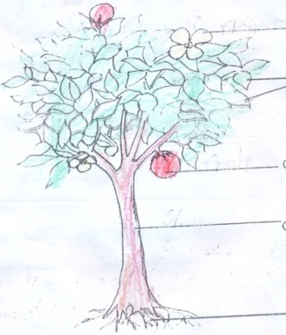
flower
leaves

fruit
stem

roots
Exercise
- Draw and name examples of plants in our environment
- Name the major parts of a plant
- Fill in the missing letters
St __m r__ __ts l __ __ves
- Draw these fruits
Mango pineapple
Oranges

- Identify the four elements of weather
- Draw the following
Rain coat

Date | Class | L. Area | No. of children | Time
THEME : Our environment
SUBTHEME : Plants in our environment
COMPETENCES : A Learner
- Writes the words correctly
- Identifies the importance of plants
- Mentions ways we care for plants
- Reads, spells and pronounces the words correctly
Text book teaching
METHODS : Brain storming
- Observation
Examples of plants
Banana plant bean plant mango plant
Cassava plant sugarcane plant
CONTENT : Importance of plants
- We get food
- We get local medicine
- We get fruits
- We get fire wood/ charcoal
- We get timber
- We sell and get money
- Flowers are used for decoration
- Plants are used for shade
- Plants give us oxygen
Ways we care for plants
- By watering them
- By spraying
- By weeding them

Cash crops
These are crops grown for sale e.g
Coffee , cotton , cocoa, vanilla, sugar cane etc
Weeds
These are un wanted plants in the garden
Exercise
- Give three ways we care for plants
- Give two uses/ importance of plants
- Draw Musa watering plants.
- _____ are un wanted plants in the garden
- Circle cash crops
Maize coffee matoke cotton
- Draw a banana plant
- Name these things we get from plants

Date | Class | L. Area | No. of children | Time
THEME : Our environment
SUBTHEME : Insects
COMPETENCES : A Learner
- Reads, spells and pronounces the words correctly
- Identifies harmful and useful insects
- States uses of insects
- Writes the words correctly
METHODS : Questions and answer
- Observation
- Guided discovery
CONTENT : Insects
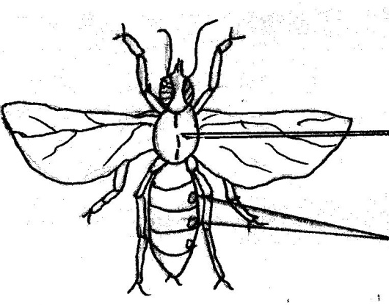
There are two types of insects

Thorax
Wings

Head
Legs
Harmful insects (dangerous) e.g.
- Mosquitoes
- houseflies,
- tsetse flies,
- cockroach
Useful insects
- Grass hoppers
- White ants
- Bees
Uses of insects
- Bees give us honey
- Grasshopper and white ants are eaten as food
Exercise
- Identify three useful insects
- State any two insects which we eat
- Which insect give us honey
- Draw the following insects
Housefly | Grass hopper

- We have two types of insects.
- Listen and write
- Write your school motto
Date | Class | L. Area | No. of children | Time
THEME : Our environment
SUBTHEME : Things that damage our environment
COMPETENCES : A learner
- Identifies ways we damage our environment
- Reads, spells and pronounces words correctly

METHODS : Guided discussion
- Guided discovery
- Question and answer

CONTENT : Things that damage our environment
These are things/ activities done by man that destroy the environment
- Burning bushes
- Cutting trees
- Poor waste disposal e.g. polythenes
- Air pollution
- Over grazing
- Bad digging methods
- Hunting and killing wild animals
- Building in swamps
Exercise
- Underline things which damage our environment.
Sitting, bush burning , playing , overgrazing, cutting trees.
- Fill in the missing letters.
Cut t__ng p __llut__ion
- Draw father cutting trees.
- Draw father cutting trees
- Name box

- Circle effects of accidents
Death happiness lameness pain

Date | Class | L. Area | No. of children | Time
THEME : Our environment
SUBTHEME : Ways of protecting our environment
COMPETENCES : A Learner
- Identifies ways of protecting the environment
- Reads, spells and pronounces words correctly

METHODS : Questions and answer
- Observation
- Guided discussion
- Guided discovery
CONTENT : Ways of protecting our environment
- Planting trees
- Good waste disposal
- Stop over grazing
- Do not burn grass
- Use good farming methods
- Stop cutting down trees
- Avoid building in swamps
Exercise
- Draw yourself planting trees
- Write down two ways of protecting our environment
- Write down any two things that damage our environment.
- Listen and write
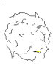
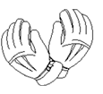
- Name things found in a first aid box

- Identify four people in an extended family
End of theme test environment
- __________ are natural surroundings of man
- Give four components of the environment
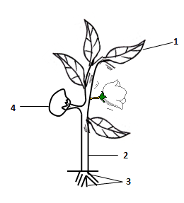
- Name the parts of a plant

- What are living things
- Give four examples of living things in an environment
- Name these non – living things in our environment

- Give four characteristics of living things
They __________
They __________
They __________
- Write their young ones
Cow man frog
Cat sheep frog
- What are domestic animals?
- Match animals sounds
Cow croaks
Lion mows
Cat roars
Frog mews
- Tick ways we care for plants
- By burning
- By watering
- By staking
- By sun drying
- Draw and name three wild animals
LESSON
What is environment?
These are the things around us.
Things in our environment
people, mountains, animals, hills, plants, swamps, chairs, water, lakes, insects, stones, building etc

Living things in our environment
Living things have life.
Characteristics of living things
- Living things reproduce
- Living things respire.
- Living things grow.
- Living things excrete
- Living things feed
- Living things move.
Lesson
Living things
There are two types of living things
- Plants
- Animals
Examples of plants
- mango plants
- orange plants
- cotton plants
- pawpaw plants

Question
- Draw and name any four livings things
Uses of plants in our environment
- Plants give us food
- Some plants give us shade.
- Some plants give us local medicine
- Plants give us oxygen
- We get charcoal from some plants
- Some plants give us timber and poles.
LESSON
Parts f a plant
These are:
- leaves
- stem
- roots
- roots
Other parts of a plant
- flower
- fruit
- bud
- terminal bud
- branches

Diagram of a plant

- We eat the leaves of these plants
- cabbage
- onions
- dodo
- nakati
- sukuma wiki
- We eat the fruits of these plants
- oranges
- pineapples
- pawpaw
- mangoes
- tomatoes
- apples
- guavas etc
- We eat the stems of these plants.
- sugarcane
- yams

- We eat the root of these plants.
- cassava
- potatoes
- Match these plants with the parts we eat
sugarcane roots
cabbage fruit
pawpaw stem
carrot leaves

LESSON
Uses of different parts of a plant to plant.
Leaves
- Leaves provide shade to another part of a plant.
- Leaves help plants to make the their own foods
- Leaves store food for the plant.
The stem
- The stem helps the plants to stand upright.
- Some stems store food for the plant.
- Stems support other parts of the plant.
Roots
- Roots hold the plant firmly in the soil.
- Some roots store food for the plants
- Roots get water from the soil for the plant.

Uses of different parts of a plant to people
Leaves
- Some leaves are eaten as food.
- Some leaves are used as local medicines.
- Some leaves are used to cover food.
- Some leaves are used to make tea.
- Some leaves are used to make ropes, basket and mats

Flowers
- Flowers are used for decorations
- Some flowers are sued to make perfume.
- Some flowers are given as gifts.
- We use flowers as wreaths
Stem
- Some stems are eaten as food.
- Some stems are sued as local medicine
- We get timber and poles from stems
Roots
- Some roots are eaten
- Some roots are sued as local medicine.

Date | Class | L. Area | No. of children | Time
THEME : Our environment
SUBTHEME : Uses of water
COMPETENCES : A learner
-State the uses of water
METHODS : Questions and answer
- Guided discussion
- Guided discovery
CONTENT : Uses of water
We use water for the following:-
- for bathing
- for cooking ‘
- for drinking
- for washing
- for watering plants
- for moping
- we swim in it
- for building
- for calling machines
- we use it as a type of transport
- we need it in the toilet while flushing

Activities that spoil or environment
- cutting down trees
- bush burning
- poor fishing methods
- hunting wild animals
- building in swamps or wet lands
- farming in swamps of wetlands
- poor farming methods
- brick laying
- pollution
How can we care for our environment?
- plant trees
- avoid building in swamps or wetlands
- control brick laying
- do not hunt wild animals
- avoid poor fishing methods
- avoid poor farming methods
- avoid bush burning

Date | Class | L. Area | No. of children | Time
THEME : Peace and security
SUBTHEME : Peace and security in our community
METHOD : Guided discovery
Question and answer
Explanation
COMPETENCES : A Learner
- Defines the term peace and security
- Identifies people who keep peace and security in our community
- State ways of keeping peace in the community
- Reads, spells and pronounces the words correctly
- Writes the words correctly

CONTENT : Peace
Peace is when people are free from danger.
Security
Security is when people and their property are safe from danger
Examples of people who keep peace and security in the community
- Policeman
- Soldiers
- Local Council Leaders
- Religious leaders eg. Pastors, Reverend, Imams, Sheikhs
- Lawyers
- Teachers
- Village leaders
- Police
- Army
- Judges
Way of keeping peace in the community
- Keeping law and order
- Avoid fighting
- A void killing
- A void stealing
- Doing communal work
- Providing community needs e.g water, hospitals, market, latrines etc.
Exercise
- Write five ways of keeping security in the community.
- Mention any two people that keep security at
  - School _________ ___________
  - Home _________ ___________
  - Community _________ ___________
- Draw people doing communal work
Cleaning water source

Exercise
- Fill in the missing letters
S__curity p__ __ce
P__licem__n p__ __ple
- Mention two people who keep peace and security in community
- Draw a police man

- What is the work of police man?
- Write down any four school activities
- Identify any two sources of food
- Draw a school flag

Date | Class | L. Area | No. of children | Time
THEME : Peace and security
SUBTHEME : People who keep peace and security at school
METHOD : Guided discovery
Question and answer
observation
COMPETENCES : A learner
- Defines insecurity
- Identifies people who keep security at school
- States the causes of insecurity in our community.
- Reads pronounces and spells correctly
- Writes correctly

Insecurity
This is when people and their property are not safe.
Causes of insecurity on our community
- Poverty
- Lack of jobs
- Failure to report wrong doers
- Lack of medical service
- Poor parental guidance
Examples of insecurity
- Stealing, fighting, wars, defiling, raping, abusing

CONTENT : People who keep security at school
- Teachers
- Watch man
- Head teacher
- Matrons
- Prefects
- School neighbor
- Cooks etc.

Exercise
- Write down six people who keep peace and security at school
- Draw a watch man at the school gate.

3. What does a watch man do at school?
4. Draw these people who keep peace and security at school
Teacher cooks
- Write places where we find the following
- Buses __________ aeroplanes train ____________
- Mention the three colours of traffic lights

Date | Class | L. Area | No. of children | Time
THEME : Peace and security
SUBTHEME : Peace and security at school
METHOD : Guided discover
Question and answer
Explanation
COMPETENCES : A learner
- Identifies factors that promote peace and security at school
- States the cause of insecurity in our school
- Reads, spells and pronounces words correctly
- Writes the words correctly

CONTENT : Ways that promote peace and security at school
Examples
- Playing together
- Working together loving one another
- Sharing
- Helping one another
- Respecting each other
- Providing basic needs in homes for the school
- Obeying rules and regulations

Causes of insecurity at school
- Playing bad games
- Refusing to respect leaders stealing
- Lack of security at school teasing
- Dangerous things at school fighting
- Not providing school needs
- Failure to obey school rules and regulation
- Child abuse at school punishment using corporal at school
- Stealing people’s property.
How to promote peace and security at school
- Observing class and school rules eg
- Having good relationships with others
- Working well with others
- Sharing with others
- Playing good games with others
- Be hard working and helpful

Exercise
- Listen and write
- Write six causes of insecurity at school.

- Write down five ways we keep peace and security
- Draw children playing together

- Name any two plants where by we eat leaves.
- Draw a sugar cane
- Draw and name three accidents at home

Date | Class | L. Area | No. of children | Time
THEME : Peace and security
SUBTHEME : People who keep security at home
METHOD : Guided discovery
Question and answer
Brain storming
COMPETENCES : A learner
- Identifies people who keep security at home
- States ways of promoting peace and security at home.
- Reads, pronounces words correctly.
- Writes the words correctly
CONTENT : People who keep security at home

- Father
- Mother
- Elder brothers
- Elder sisters
- Grand father
- Grand mother
- Uncle
- Aunt
- Workman

Ways to promote peace and security at home
- Greeting one another.
- Greeting our parents
- Obeying rules at home/ parents
- Respecting people at home
- Doing house work together
- Praying together
- Showing love to one another

Exercise
- Fill in the missing
F_th_r a_nt p__ ___ce sec __rity
- Write five people who keep security at home.
- Draw these people who keep peace and security at home.
Father | Mother | Grandfather | Uncle

- Underline things that cause insecurity at home
- Circle things that promote peace and security.
- Why do we wash our hands before eating?
- What makes food go bad?

Date | Class | L. Area | No. of children | Time
THEME : Peace and security
SUBTHEME : Causes of insecurity at home
METHOD : Guided discovery
Question and answer
Brain storming
COMPETENCES : A learner
- States ways of promoting peace and security at home.
- Identifies causes of insecurity at home
Text book teaching
CONTENT : Causes of insecurity at home
- Lack of basic needs
- Child abuse
- Neglecting homes
- Lack of love at home
- Lack of medical care
- Quarrels among parents
- Disobedience of children
- Having bad neighbours
- Quarreling and fighting among family members
- Laziness and not being helpful
How we can promote peace and security at home
- Promote co-operation among family members
- Good behaviour
- Good health practices e.g keeping our homes clean.
- Respect of elders
- Love and are for one another
- Sharing with others

Exercise
- ______________is the situation when people are free from danger or harm.
- _______________ when people and their property are free from danger or harm.
- Write down two causes of insecurity
- Draw a child being taken to hospital
- How can you keep peace and security at home?
- Write down 2 causes of insecurity at home.

Date | Class | L. Area | No. of children | Time
THEME : Peace and security
SUBTHEME : Things which cause insecurity in homes
METHOD : Guided discovery
Question and answer
Guided discussion
COMPETENCES : A learner
- States things which cause harm at home.
- Identifies the importance of keeping peace and security
CONTENT : Things which cause harm at home

- fire
- axe
- guns
- spear
- knives
- panga
- poison
- nails
- dogs
- barbed
- wires
- perimeter walls

Things used to keep peace and security
- guns
- tear gas
- spears
- pangas
- bombs
- police dogs
- shield

Importance of keeping peace and security
- People live in peace
- People don’t fall sick
- People are educated
- The area develops
- Children respect their parents
- People share with one another
- People get all their needs
Exercise
- Write down any two ways we can keep peace and security at school
- Write down three importance of keeping peace and security
- Draw children going to school happily
- Write down four things which cause harm at home.
- Draw the following
panga | spear | gun | nail

- . Mention one thing that brings insecurity at home.

- Listen and write
- Who heads a school
- We use a _______ to write in a

Date | Class | L. Area | No. of children | Time
THEME : Peace and security
SUBTHEME : Things which cause insecurity in homes
METHOD : Guided discovery
Question and answer
Guided discussion
COMPETENCES : A learner
- States roles of people who keep peace and security in our community.
- Security in our community.
- Identifies wrong doers in our community
CONTENT : Roles of people who keep peace and security in our community

Army - protect the country
Police - keeps law and order
LD U - protects the village
Religious leaders – teach the fear of God
- teach good morals.
Parents/ elders – guide and counsel children

Wrong doers in our community
These are bad people in our community.
Examples
Thieves
Rapists
Defilers
Kidnappers
Murdered

Exercise
- Write their roles
- Police man
- LDU
- Religious leaders
- Listen and write
- Give four examples of people who cause insecurity in the community
- Draw a police man chasing a thief
- Why do we eat food?
Date | Class | L. Area | No. of children | Time
THEME : Peace and security
SUBTHEME : School needs
METHOD : Guided discovery
Question and answer
Guided discussion
Observation
COMPETENCES : Learner’s will
CONTENT : What are school needs?
- These are things needed to be used at school. Failure to get school needs can cause insecurity at school.

School needs include;
- Food
- Water
- Classroom
- Teachers
- Furniture
- Uniforms-

Exercise
- Write five school needs
- Draw the following school needs
desks | Food
External work
Lesson
Peace and security
Peace and security at home

How can we promote peace and security at home?
- good relation in a home along family members
- good health
- good behavior
- love and care
- sharing with others

What are the causes of insecurity in our homes?
- poor relationship
- lack of food
- violence / fights
- lack of respect
- laziness and not being helpful

Promoting peace and security at school
- Observing class and school rules
- have good relationship with others
for examples
- work together
- care for others
- be hard working and helpful
people who cause insecurity, thieves, rapists, drug abuses, mad people
What are the causes of insecurity in our school
- stealing people’s property
- beating or fighting other
- not following class and school rules
- lack of respect for other
The people who keep peace and security
- parents ‘
- teachers
- elders
- big brothers and sisters
- religions like pastors, priests, reverends, bishops , pope etc
- local councils
- local defence units
- lawyers
- police
- army

Importance of peace and security
- For good relationship
- for development (working together)
- promotes good health
- promote love and care.

End of theme test peace and security
- ___________ is when people and their properties are safe
- Identify four people who can keep peace and security in the community
- Name these things used to keep peace and security in the community
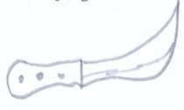

- Who keeps law and order in the community
- Tick people who keep peace and security at school
Baby prefect teacher doctor askari
- Draw these school needs
Books chairs pens rulers
- Give one importance of keeping peace and security _________ (people die, the area develop)
- Give two causes of insecurity at home
- Draw a watch man at the school gate

